Nate Sanchez

**Part 1: OR**

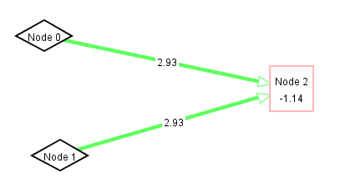

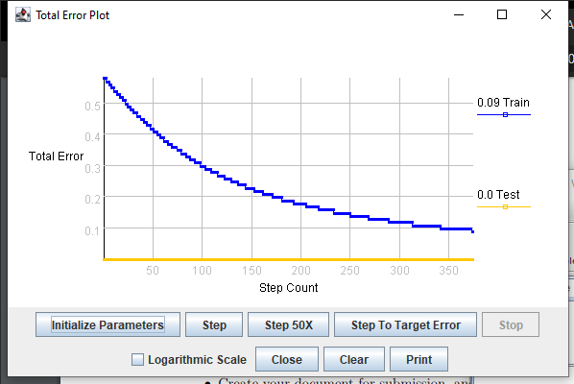

Since each node has equal importance in this scenario, it makes sense that their weights are equal. Since the weights are positive, they will be on if they receive an input of 1. The bias is helping keep everything in check and in the right direction of getting the right answer.

**Part 2: XOR**

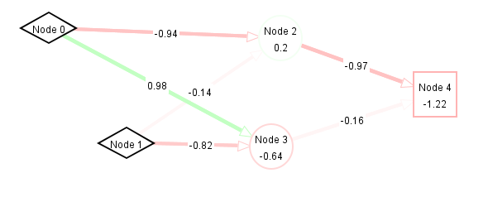

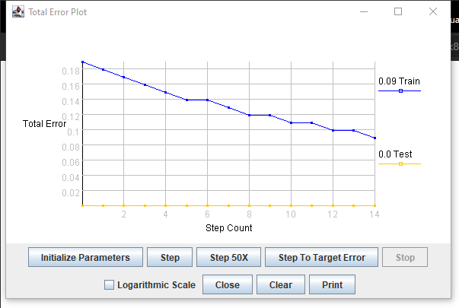

**Part 3: Mirror Symmetry**

1. 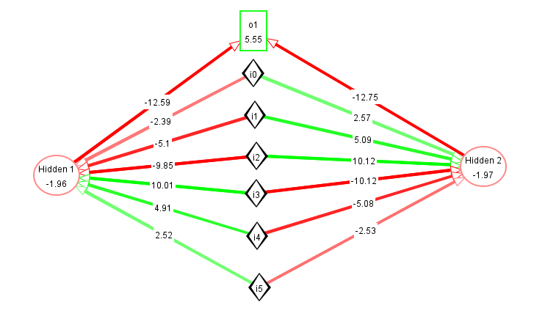
   1. The weight of the nodes mirrors each other so when symmetry is found, the hidden nodes get an input of 0. Since they have a negative bias, they will be off and the output node having a positive bias will be on. Since the weights have a ratio of 1:2:4 the nodes have unique activation sums.
   2. There was a similar symmetry in the weights but the actual wights in mine were smaller. They do still have the rough 1:2:4 ratio that example had, and the numbers are opposites (roughly) both vertically and horizontally. The weight from the hidden nodes is more negative than the example and the output node had a smaller bias. The hidden nodes were almost twice as biased when compared to the example.
2. 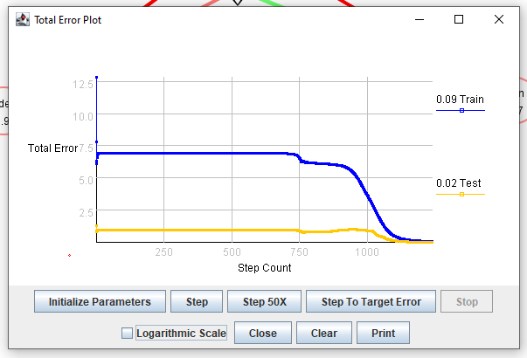

Both the test error and training error went down.

1. 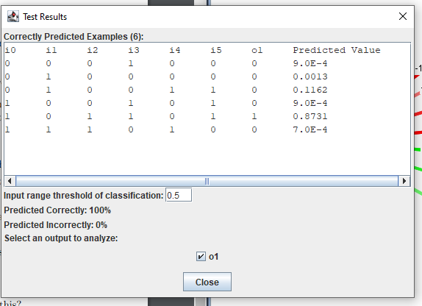
   1. Everything was predicted correctly.

**Part 4: Another Symmetry**

1. This task is very similar in how the weights and biases impact the output. However, the first three weights are mirrored by the second three weights.
2. 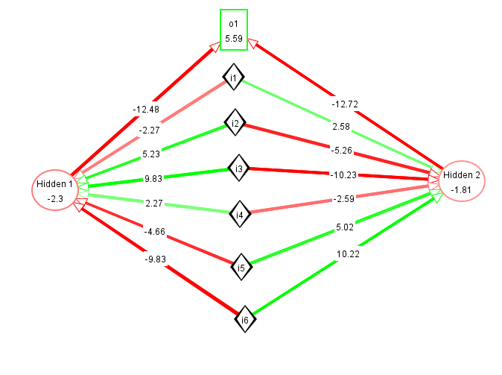
   1. The actual numbers are very similar to the mirror symmetry example except the order that they appear which corresponds with the symmetry we are looking at. From what I can tell they fundamentally function the same.
   2. The proportions of the numbers are very similar but the order that they appear is different. The biases are a little more profound in the hidden nodes and the output node has a slightly less profound bias. Once again, the weight from the hidden nodes is noticeably more profound.
3. 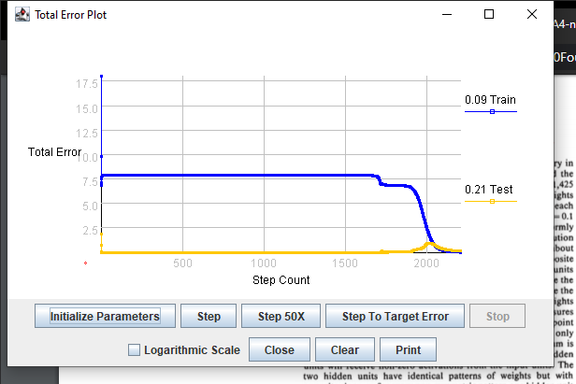

The training error went down but the test error went up before going down.

1. 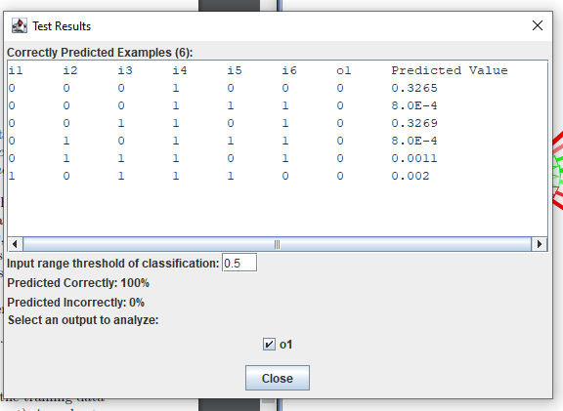
   1. Everything was predicted correctly.

**Part 5: Symmetry Gone Wild**

1. 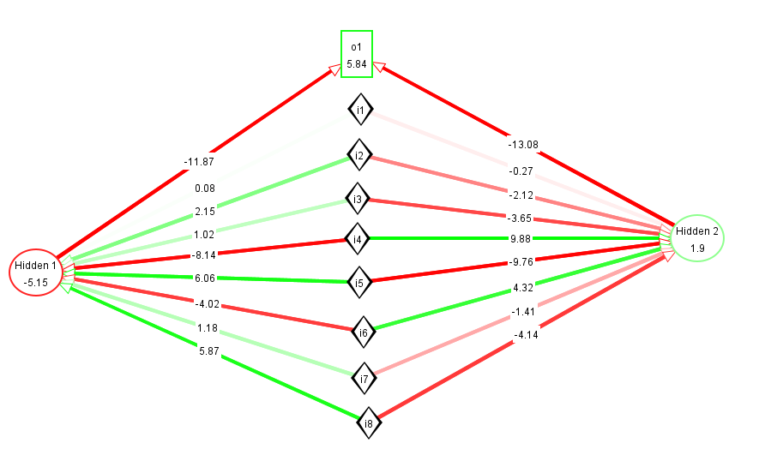
2. 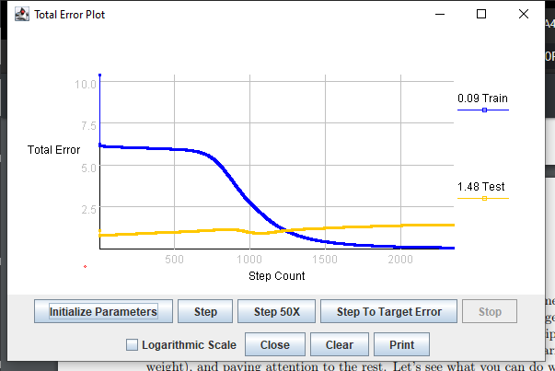

The training error went down but the test error went up.

1. 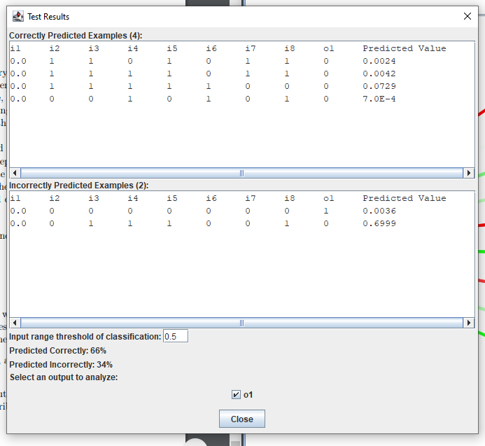
   1. Only about two thirds were predicted correctly while the other third was incorrectly predicted.